ERS – TEACHERS (updated for FY 2019 employer reporting)
Proposed Pension Note Disclosures – ERS Teacher Employer Units
(Based on Illustration 4 in GASB No. 68 – Note disclosures for employers participating in a cost-sharing plan that has a special funding situation – also refer to par. 74 to .80 and par. 109 to .113 of GASB 68)

A. THE FOLLOWING IS AN ADDITION TO THE SUMMARY OF SIGNIFICANT ACCOUNTING POLICIES
Pensions
For purposes of measuring the net pension liability, deferred outflows of resources and deferred inflows of resources related to pensions, and pension expense, information about the fiduciary net position of the Employees’ Retirement System plan (ERS) and the additions to/deductions from ERS’ fiduciary net position have been determined on the same basis as they are reported by ERS. For this purpose, benefit payments (including refunds of employee contributions) are recognized when due and payable in accordance with the benefit terms. Investments are reported at fair value.
B. THE FOLLOWING INFORMATION IS FOR INCLUSION IN THE TEACHER UNIT’S PENSION NOTES
Note X. Defined Benefit Pension Plan
General Information about the Pension Plan
Plan description - Certain employees of the (Name of Teacher Unit) participate in a cost-sharing multiple-employer defined benefit pension plan - the Employees’ Retirement System plan - administered by the Employees’ Retirement System of the State of Rhode Island (System). Under a cost-sharing plan, pension obligations for employees of all employers are pooled and plan assets are available to pay the benefits of the employees of any participating employer providing pension benefits through the plan, regardless of the status of the employers’ payment of its pension obligation to the plan. The plan provides retirement and disability benefits and death benefits to plan members and beneficiaries.
The System issues a publicly available report that includes financial statements and required supplementary information for the plans. The report may be obtained at http://www.ersri.org.

Benefit provisions – The level of benefits provided to participants is established by Chapter 36-10 of the General Laws, which is subject to amendment by the General Assembly. Member benefit provisions vary based on service credits accumulated at dates specified in various amendments to the General Laws outlining minimum retirement age, benefit accrual rates and maximum benefit provisions. In general, members accumulate service credits for each year of service subject to maximum benefit accruals of 80% or 75%. For those hired after June 30, 2012, the benefit accrual rate is 1% per year with a maximum benefit accrual of 40%. Members eligible to retire at September 30, 2009 may retire with 10 years of service at age 60 or after 28 years of service at any age. The retirement eligibility age increases proportionately for other members reflecting years of service and other factors until it aligns with the Social Security Normal Retirement Age, which applies to any member with less than 5 years of service as of July 1, 2012. Members are vested after 5 years of service.
The plan provides for survivor’s benefits for service connected death and certain lump sum death benefits. Joint and survivor benefit provision options are available to members.

Cost of living adjustments are provided but are currently suspended until the collective plans administered by ERSRI reach a funded status of 80%. Until the plans reach an 80% funded status, interim cost of living adjustments are provided at four-year intervals commencing with the plan year ending June 30, 2016.

The plan also provides nonservice-connected disability benefits after five years of service and service-connected disability benefits with no minimum service requirement.

Contributions - The funding policy, as set forth in the General Laws, Section 16-16-22, provides for actuarially determined periodic contributions to the plan. For fiscal 2019, (Name of Teacher Unit) teachers were required to contribute 3.75% of their annual covered salary, except for teachers with twenty or more years of service as of June 30, 2012 must contribute 11% of their annual covered salary. The state and the (Name of Teacher Unit) are required to contribute at an actuarially determined rate, 40% of which is to be paid by the state and the remaining 60% is to be paid by (Name of Teacher Unit); the rates were XX% and XX % of annual covered payroll for the fiscal year ended June 30, 2019 for the state and (Name of Teacher Unit), respectively. The (Name of Teacher Unit) contributed $X,XXX,XXX, $X,XXX,XXX and $X,XXX,XXX for the fiscal years ended June 30, 2019, 2018 and 2017, respectively, equal to 100% of the required contributions for each year. (Contribution amount for FY 2018 must agree with amount on Page 5 of “Schedule of Pension Amounts by Employer” and the amount for FY 2019 must agree with amount reported by ERSRI). The State’s share of contribution for fiscal 2019 was $XXX,XXX and is reported as on-behalf payments and included in both revenue and expenditures on the financial statements.

Pension Liabilities, Pension Expense, and Deferred Outflows of Resources and Deferred Inflows of Resources

At June 30, 2019, the (Name of Teacher Unit) reported a liability of $X,XXX,XXX (Source: column entitled “Ending Net Pension Liability” on “Schedule of Pension Amounts by Employer”) for its proportionate share of the net pension liability that reflected a reduction for contributions made by the state. The amount recognized by the (Name of Teacher Unit) as its proportionate share of the net pension liability, the related state support and the total portion of the net pension liability that was associated with the (name of Teacher Unit) were as follows:

(Name or Teacher Unit) proportionate share
Amounts from Schedule F
of the net pension liability $XXXX

State’s proportionate share of the net pension
liability associated with the (Name of Teacher Unit) $XXXX

Total net pension liability

The net pension liability was measured as of June 30, 2018, the measurement date, and the total pension liability used to calculate the net pension liability was determined by an actuarial valuation as of June 30, 2017 rolled forward to June 30, 2018. The (Name of Teacher Unit) proportion of the net pension liability was based on a projection of the (Name or Teacher Unit) long-term share of contributions to the pension plan relative to the projected contributions of all participating employers and the State, actuarially determined. At June 30, 2018 the (Name of Teacher Unit) proportion was X.XX% (Source: column entitled “Proportionate Share” on page 5 in “Schedule of Pension Amounts by Employer”).

For the year ended June 30, 2019 the (Name of Teacher Unit) recognized gross pension expense of $X,XXX,XXX) and revenue of $XXXX for support provided by the State (Source: Schedule E). At June 30, 2019 the (Name of Teacher Unit) reported deferred outflows of resources and deferred inflows of resources related to pensions from the following sources:

Deferred outflows of resources
Contributions subsequent to the measurement date
Difference between expected and actual experience
Change in assumptions
Net difference between projected and actual earnings on pension plan investments
Changes in proportion and differences between employer contributions and proportionate share of contributions
Deferred inflows of resources
Difference between expected and actual experience
Changes in assumptions
Changes in proportion and differences between employer contributions and proportionate share of contributions
Net difference between projected and actual earnings on pension plan investments
Total

Deferred outflow and inflow data is contained in columns in “Schedule of Pension Amounts by Employer” except for contributions subsequent to measurement date.

$X,XXX,XXX reported as deferred outflows of resources related to pensions resulting from the (Name of Teacher Unit) contributions in fiscal year 2019 subsequent to the measurement date will be recognized as a reduction of the net pension liability in the subsequent period. Other amounts reported as deferred outflows of resources and deferred inflows of resources related to pensions will be recognized in pension expense as follows:

Year ended June 30:
2020 | Amounts from Schedule D
2021
2022
2023
2024
thereafter

Dollar amounts for each year to be obtained from OAG issued – Schedule of Pension Amounts by Employer - use line for your entity. See – Schedule D

Actuarial Assumptions - the total pension liability was determined using the following actuarial assumptions, applied to all periods included in the measurement:

Inflation 2.5%

Salary increases 3.0% to 13.5%

Investment rate of return 7.0%

Mortality – variants of the RP-2014 mortality tables - for the improvement scale, update to the ultimate rates of the MP-2016 projection scale.

The actuarial assumptions used in the June 30, 2017 valuation rolled forward to June 30, 2018 and the calculation of the total pension liability at June 30, 2018 were consistent with the results of an actuarial experience study performed as of June 30, 2016.

The long-term expected rate of return best-estimate on pension plan investments was determined by the actuary using a building-block method. The actuary started by calculating best-estimate future expected real rates of return (expected returns net of pension plan investment expense and inflation) for each major asset class, based on a collective summary of capital market expectations from 34 sources. The June 30, 2018 expected arithmetic returns over the long-term (20 years) by asset class are summarized in the following table:

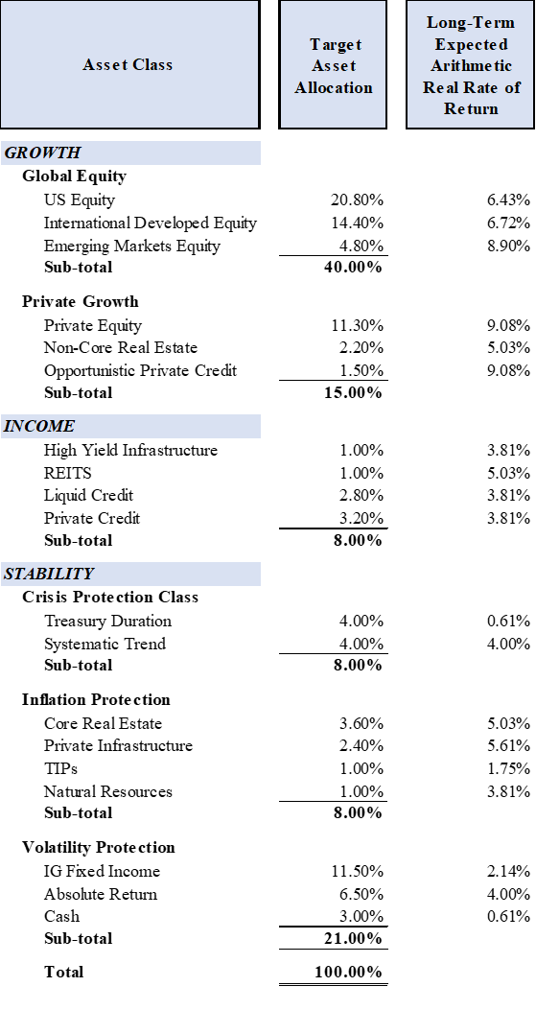
These return assumptions are then weighted by the target asset allocation percentage, factoring in correlation effects, to develop the overall long-term expected rate of return best-estimate on an arithmetic basis.

Discount rate - the discount rate used to measure the total pension liability was 7.0 percent. The projection of cash flows used to determine the discount rate assumed that contributions from plan members will be made at the current contribution rate and that contributions from the employers will be made at statutorily required rates, actuarially determined. Based on those assumptions, the pension plan’s fiduciary net position was projected to be available to make all projected future benefit payments of current plan members. Therefore, the long-term expected rate of return on pension plan investments was applied to all periods of projected benefit payments to determine the total pension liability.

Sensitivity of the net pension liability (asset) to changes in the discount rate - the following presents the proportionate share of the net pension liability (asset) calculated using the discount rate of 7.0 percent as well as what the net pension liability (asset) would be if it were calculated using a discount rate that is 1-percentage-point lower or 1-percentage-point higher than the current rate.

1.00% Decrease  (6.0%) | Current Discount Rate  (7.0%) | 1.00 Increase  (8.0%)

Dollar amounts for each year to be obtained from OAG issued – Schedule of Pension Amounts by Employer - use line for your entity. – See Schedule D

Pension plan fiduciary net position - detailed information about the pension plan’s fiduciary net position is available in the separately issued ERSRI financial report.

Notes to the financial statements - when employees are covered by more than one plan

The total (aggregate for all pensions, whether provided through single-employer, agent, or cost-sharing pension plans) of the employer’s pension liabilities, pension assets, deferred outflows of resources and deferred inflows of resources related to pensions, and pension expense/expenditures for the period associated with net pension liabilities should be disclosed if the total amounts are not otherwise identifiable from information presented in the financial statements. (par. 37 GASB 68)

Disclosures related to more than one pension plan should be combined in a manner that avoids unnecessary duplication. (par. 38 GASB 68)

Note X. Defined Contribution Pension Plan
Defined Contribution Plan Description:
Employees participating in the defined benefit plan with less than 20 years of service as of June 30, 2012, as described above, also participate in a defined contribution plan authorized by General Law Chapter 36-10.3. The defined contribution plan is established under IRS section 401(a) and is administered by TIAA-CREF. Employees may choose among various investment options available to plan participants. Employees contribute 5% of their annual covered salary and employers contribute between 1% and 1.5% of annual covered salary depending on the employee’s total years of service as of June 30, 2012. Employee contributions are immediately vested while employer contributions and any investment earnings thereon are vested after three years of contributory service. Benefit terms and contributions required under the plan by both the employee and employer are established by the General Laws, which are subject to amendment by the General Assembly.

Amounts in the defined contribution plan are available to participants in accordance with Internal Revenue Service guidelines for such plans.

The (Name of Teacher Unit) recognized pension expense of $XXX,XXX, for the fiscal year ended June 30, 2019.

The System issues a publicly available financial report that includes financial statements and required supplementary information for plans administered by the system. The report may be obtained at http://www.ersri.org.

To facilitate one Defined Contribution Note that may address multiple classes of employees - See contribution rates for various employee categories and report what is applicable:
 |  | EE contribution | ER contribution
ERS members
 | ERS - teachers - contribute to Social Security - less than 20 years of service at 7/1/2012 | 5% | 1% to 1.5% depending on years of service
 | ERS – teachers – do not contribute to Social Security - less than 20 years of service at 7/1/2012 | 7% | 3% to 3.5% depending on years of service
 | ERS – teachers – more than 20 years of service on July 1, 2012 | No DC plan contributions (ee and er) after July 1, 2015
MERS members
 | MERS Public Safety members that do not contribute to Social Security | 3% | 3%
 | MERS Public Safety members that also contribute to Social Security | No DC plan participation
 | MERS general ee’s that do not participate in Social Security – have less than 20 years of service at 7/1/2012 | 7% | 3% to 3.5% depending on years of service
 | MERS – general employees who contribute to Social Security – and had less than 20 years of service on July 1, 2012 | 5% | 1% to 1.5% depending on years of service
 | MERS – general employees – more than 20 years of service on July 1, 2012 | No DC plan contributions (ee and er) after July 1, 2015

